You can now download the rehearsal music files from our website so that you can save them to your own computer then use them as you wish, for example to make a CD to play in the car. Here's how...
Go to the website, and select the "Members Only" page and enter the password "happiness".
You will see a screen like this:
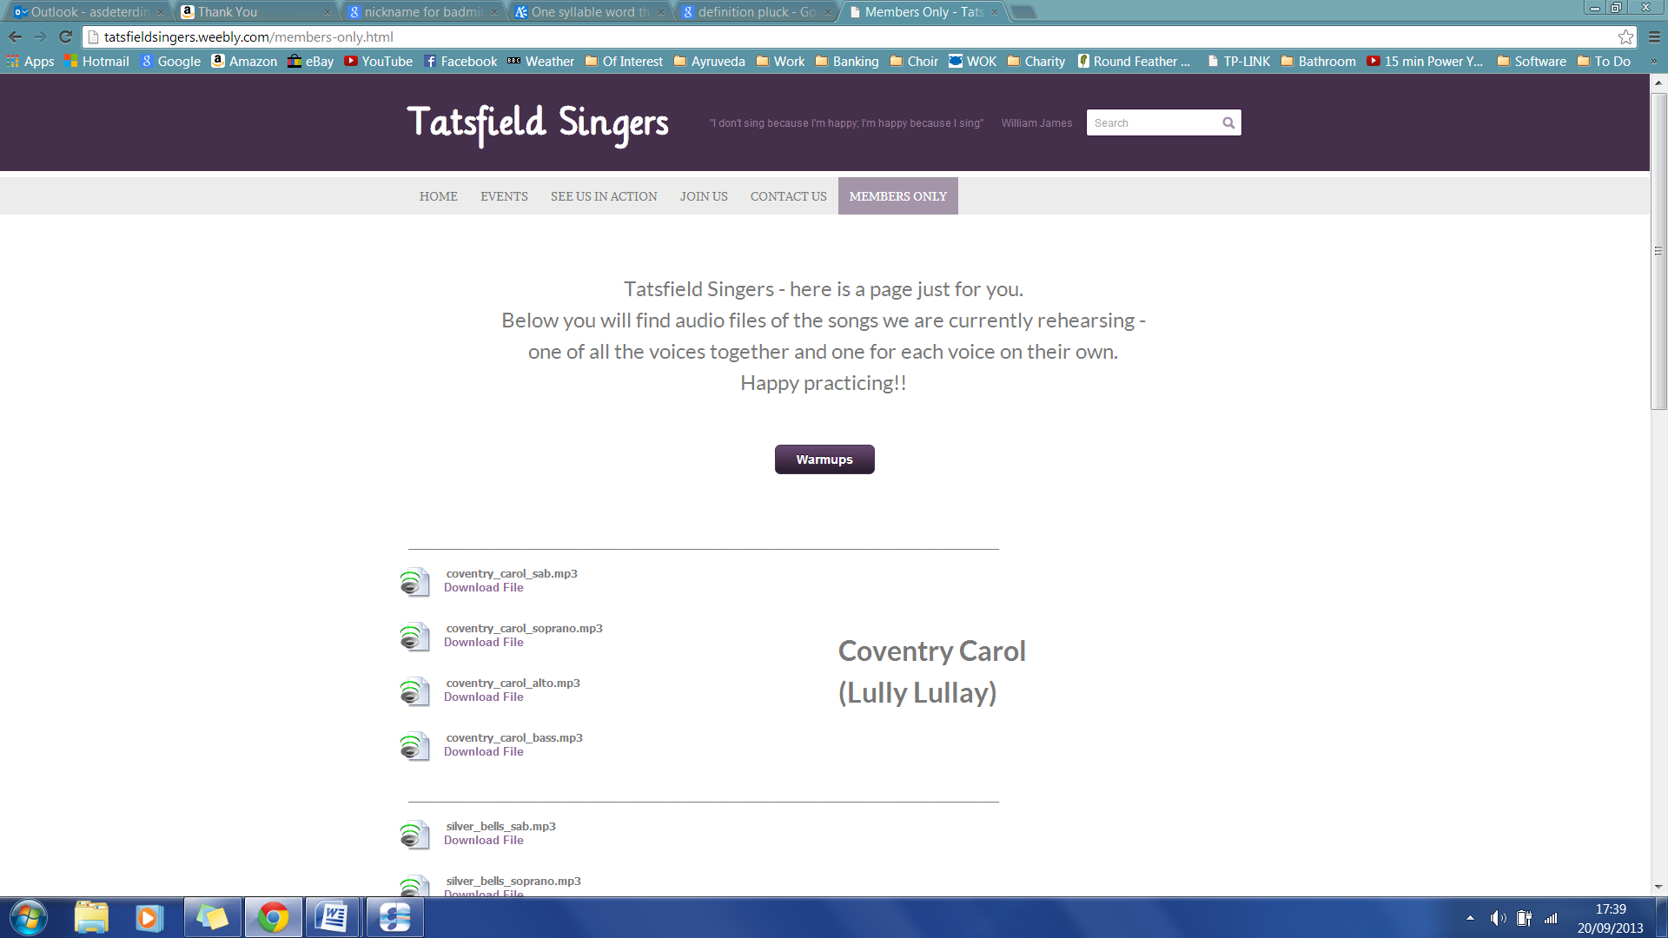
Each song will have four/five files (apart from unison songs). The first in each list contains all three parts together followed by a file for each voice separately.
Click on "Download File" under the one you want and the following screen will appear:
...which will automatically play the file for you.

If you want to download the file, right click anywhere on the screen and a menu will appear:
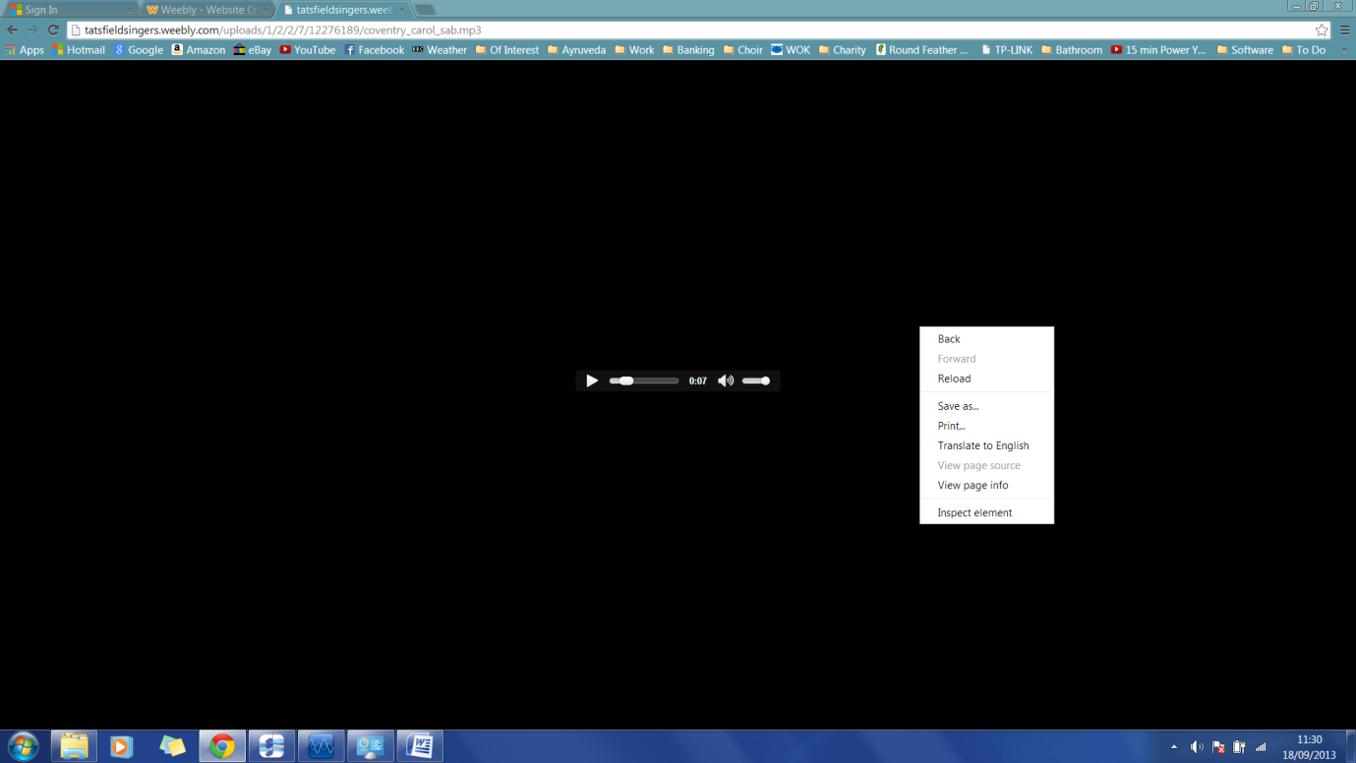
Select "Save As" and then you can save the file to your computer.
To return to the Members Only page just use your back button.

